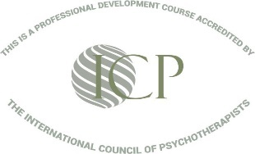

ADVANCED STUDY 2022: INTENSIVE TRAINING in COGNITIVE BEHAVIOURAL THERAPY (CBT)
Course Description:
Diploma in CBT and the Psychology of Depression, Grieving & Loss
Dates: Part One Sat 8th - Sun 9th October 11.00 am - 7.00 pm (GST)
Part Two Sat 22nd - Sun 23rd October 11.00 am - 7.00 pm (GST)
The theory and practice of CBT and how to combine with hypnotherapy and other complementary psychotherapeutic modalities. The course covers the psychology of depression, grieving and loss (4-days total)
This short intensive course has UK accreditation and is suitable for mental health professionals and others with relevant backgrounds/experience in the caring, health and well-being professions who wish to learn and apply the basic principles and practices of CBT along with other modalities to incorporate into their existing skill-set. Contact the Course Leader if in doubt as to your eligibility. The Diploma in CBT with the Psychology of Depression, Grieving and Loss is awarded on passing the post-course exam at the required standard (accredited by Dr David Kato, ACHE, APHP, NCP/ICP, and the Open College, UK).
CBT has become increasingly popular with clinicians and the general public alike, over recent years, and it was the therapy recommended as a replacement for most drug-based therapy in the highly influential Depression Report published by the London School of Economics in 2006. The Report recommended a radical shift in health policy, away from prescription medications and towards the provision of “short, effective, evidence-based psychological therapies” that help people to build on the positive side of their personalities, particularly CBT. These recommendations were strongly endorsed by the U.K.’s National Institute for Health and Clinical Excellence (NICE), the Mental Health Foundation, the American Psychiatric Association (APA), and many other organisations dedicated to improving mental health, including: MIND, Rethink, the Sainsbury Centre for Mental Health, Young Minds. CBT has become a favourite choice of care with companies and health services looking for cost-effective alternatives to traditional psychotherapy. Its popularity is partly because of its common sense and clear principles, and also because the short, structured nature of the treatment makes it particularly amenable to empirical investigation, and it has accumulated an impressive research base.
The government responded favourably to these recommendations at the time and, following the success of pilot projects in 2007, National Health Service policy has been steadily shifting towards the implementation of this new approach. For political and economic reasons progress has been slow but even if funding is increased, there is the problem that there is a shortage of suitably trained and qualified therapists to meet the increasing demand.
Studies indicate that CBT is superior to anti-depressants and has even been shown to be an effective treatment for schizophrenic patients in clinical settings. It is not surprising that CBT is now included in most treatment guidelines for a variety of psychiatric conditions.
GPs are encouraging their patients to seek help from CBT therapists because of its evidence-based results. CBT has been proved to gain superior outcomes, as compared with other talk-based therapeutic approaches, with fast results in the short-term, and often with long-lasting benefits. In this respect, CBT, like hypnotherapy, can be accurately described as a form of ‘brief therapy’.

Many studies have demonstrated that when combined with hypnotherapy, the success rates are even higher, so this short intensive course covers the key principles and methods of CBT and how it can be combined with hypnotherapy as ‘Hypno-CBT’ or ‘Cognitive Behavioural Hypnotherapy’ to achieve better outcomes with clients who present with depression, grieving and loss, and how a combination of both approaches can be beneficial for clients. It includes an introduction to mindfulness and alternative views of the process of dying and death from the perspective of Eastern and Buddhist Psychology, which are increasingly influential in the latest versions of CBT, such as Dialectical Behavioural Therapy (DBT) and Mindfulness-based CBT.

ABOUT THE TRAINING:
This course is held over 4 intensive days over 2 weekends. Personal study to be conducted before and after the online sessions (reading, viewing, listening, research, and case studies), with a final post-course exam (AED 300 marking and certification fee is included in the fee. Successful completion at the required standard (75% minimum pass mark in both parts of the paper) leads to the award of the Diploma.

DETAILED CURRICULUM:
PART 1: DIPLOMA IN COGNITIVE BEHAVIOURAL THERAPY (CBT)
Part 1 provides an overview of the history and development of CBT, the basic structure of theory and practice, different approaches within CBT and incorporating CBT into Hypnotherapy and other modalities:
History of CBT
- CBT Basics – Key Points of Theory
- Goals of CBT
- The Stages of CBT
- Beck’s CBT and Evidence-Based Research on CBT outcomes
- CBT and Hypnotherapy: similarities and differences
- CBT is flexible and can be used in a complementary way to other modalities
- A 50-50 form of therapy where the client is responsible for follow up action – and progress
- The Use of Forms & Written work: Homework and Self-Help Assignments within the CBT framework & Case Studies to consider
- Helping Clients to start identifying and challenging negative/dysfunctional beliefs.
- Initial Consultation and Assessment, Building & Maintaining Rapport, Using Audio-materials
- A Plan of Action, ‘ABC’s, Socratic Questioning
- Vertical Descent and Other Techniques: Test/Challenge Negative & Catastrophic Thinking – Reframing to Elicit Change
- Structured 6–session approach including Hypno-CBT and some NLP techniques
- Client feedback and Evidence-Based Outcomes, Conclusion of Sessions.
- Suicidal Ideation, OCD, Anger Management

PART 2: THE PSYCHOLOGY OF DEPRESSION, GRIEVING & LOSS (CBT)
The second part of the course focuses on the psychology of depression, bereavement, grieving, and loss and also on the current medical model of mental illness, as detailed in the Diagnostic and Statistical Manual (DSM-V) which is prevalent internationally.
Whilst there are fundamental flaws in this model, it is important that professional practitioners have a sound understanding of the model in order to work constructively with medical and health professionals and to encourage their clients/patients to educate themselves in order to achieve the best possible therapeutic and well-being outcomes.

The curriculum covers:
- An overview of Depression – the Medical Model and Medication
- DSM V Categories and Labels
- Different Treatment Modalities: Analytical & CBT
- Case Study of Multiple Issues
- The Initial Consultation and a Plan of Action
- Suicidal Ideation & Risk Factors
- Depressive Thinking
- Ante- and Post-Natal Depression
- Bipolar Behaviours
- Death: Different Perspectives based on Mahayana Buddhist Psychology and Eastern Philosophy
- The Stages of Grieving and the Khubler-Ross Model.
- ‘Normal Grief’ and ‘Abnormal/Complicated Grief’?
- Myths and Facts about Grieving
- Techniques for Working with Depression, Grieving and Loss
- Case Studies

YOUR INVESTMENT
The standard fee for this course, including a substantial amount of materials and resources for immediate use and the exam and certification fee is AED 3,900
Those who register and pay by the Earlybird date will pay just AED 3,500
Early registration is recommended as there are limited places on this course.

DIPLOMA in EATING DISORDERS and OCD
This is an additional course which is particularly useful to those who work in the field of nutrition and health as well as being a valuable extra for those who have completed the CBT Diploma.
The Psychology of Eating Disorders and OCD. How to use CBT with clients and combining treatment with hypnotherapy and other complementary psychotherapeutic modalities. (2 days total)
This course is also presented by Dr. Leila Edwards, Principal of Transformations Institute and provides a very useful additional qualification to the Diploma in CBT. The Diploma in Eating Disorders and OCD is awarded on passing the post-course exam.

The Training

A short intensive course designed for therapists, hypnotherapists, psychotherapists, counsellors, well-being coaches, psychologists, health and medical professionals, including nutritionists and dieticians, educators with pastoral roles, and anyone trained in relevant modalities who wish to learn more about the psychology and effective therapeutic interventions for clients/patients presenting with Eating Disorders and/or OCD.

The course will cover how evidence-based Cognitive Behavioural Therapy (CBT) and Hypnotherapy techniques can be incorporated into clinical practice and enhance the practitioner’s skill-base. Participants will be provided with extensive course materials for immediate use.

‘Anorexia Nervosa’, ‘Bulimia’ and other ‘Eating Disorders’ present different ‘symptoms’, but all have some commonalities, which they also share with ‘OCD’. This course was created to provide information that would be useful to therapists and others in the helping professions and thus promote understanding, awareness, and knowledge in order to enable participants to provide more effective therapeutic support for clients who seek their professional assistance.

Dr Leila Edwards, Course Leader
drleila@transforminst.com
Whatsapp/SMS: 00212 (0) 771 099 501

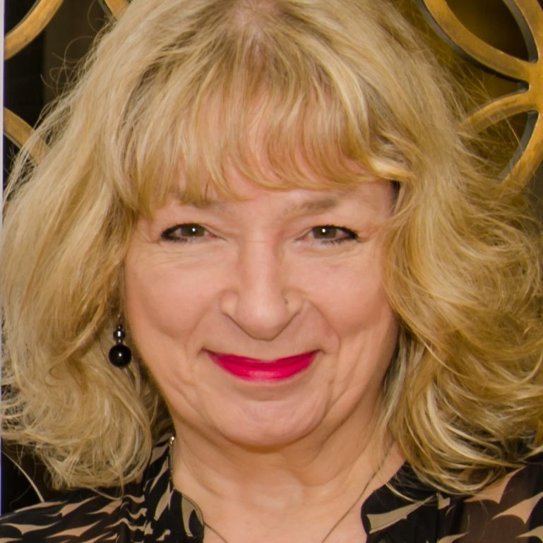
ABOUT DR LEILA EDWARDS:
Title: Senior Consultant, Supervisor & Accredited Trainer, Principal of Transformations Institute
Wholistic Approaches Include:
- Clinical Hypnotherapy, Psychotherapy & Counselling
- Cognitive Behavioural Therapy (CBT)
- Neuro-Linguistic Programming (NLP)
- Couples, Relationship, and Family Counselling
- Personal and Corporate Coaching
- Emotional Intelligence (EQ)
- Effective Communication and Influencing Skills
- Emotional Freedom Techniques & Meridian Therapies
- Integrative Breathwork
- Preparation for Positive Childbirth & Parenting, including Active Hypnobirthing
Services Offered:
- Private Consultations for Individuals, Couples, and Families
- Awareness-raising Workshops & Seminars, including free Webinars
- Corporate Wellness Programmes and Trainings
- Internationally Accredited Training in Integrative Psychotherapy, including Client-Centred Counselling, CBT, Clinical Hypnotherapy, Meridian Therapies, and Breathwork, leading to the award of UK-accredited Diplomas.

Current and Previous Memberships, Public Service and Honours:
Diplomate (Lifetime Honorary Member – by invitation only) of and Approved Supervisor and Trainer for the Association for Professional Hypnosis and Psychotherapy (APHP)
Fellow of and Accredited Trainer and Supervisor for the National Council of Psychotherapists (NCP)
Member of the National Register of Psychotherapists and Counsellors (NRPC)
Member of the James Braid Society
Member of the National Association for Cognitive Behavioural Therapists (NACBT)
Senior Member of the General Hypnotherapy Register (GHR)
Registered with the Complementary and Natural Healthcare Council (CNHC)
Fellow of the Royal Society of Arts (RSA)
Elected Convenor of the British Rebirthing Society (BRS)
Honorary Member of the Golden Key International Honours Society
Member of MENSA
Chair of the Advisory Board to Austin Training International
Elected Member of the Community Health Council, representing the NCT
Member of the Confidence and Assertiveness Trainers (CAT) Forum, UK
Member of the Southwest Committee of the Widening Participation Initiative
Member of the British Association for Counselling (BAC)
Governor, City of Bath College
Member of the Staff Team and Team Leader for the Open University Business School MBA programme team, specializing in Creativity, Innovation & Change.
Member and Accredited Trainer of the National Register of Advanced Hypnotherapists (NRAH)
Member of the British Association of Counselling (BAC) and a member of a National Committee of the Association of Student Counsellors (ASC)
Honored with a ‘Women of the West’ award for outstanding contribution to lifelong learning
Honored twice with the “School of the Year” award as Principal of Transformations Institute, out of the global network of APHP-accredited schools.
Dr Leila has spent her life dedicated to promoting applied positive psychology in human development in all of her many and varied roles. As an educator, she has taught at all levels and ages and served as a University Dean and Director. She has been active in initiatives to widen participation and enable entry to further, higher and adult learning for all those who wish to develop personally and professionally, especially women and under-represented groups. She is committed to client- and person-centered therapy, counseling, coaching and teaching and to focusing holistically on the needs of individuals, rather than imposing labels on people. She was the co-founder of the North London Therapy Centre and the Total Relaxation Centre, UK, and served as an Inspectorate Advisor in Equal Opportunities to the Inner London Education Authority (ILEA), developing the curriculum and appointing a dedicated team of specialists to deliver Assertiveness and Confidence Training across the adult education and youth service. She also established the first publicly-funded ILEA courses to provide pregnancy, childbirth, and parent education.
Dr. Leila is a mother, grandmother, and great-grandmother who is passionate about health and well-being and committed to “walking the talk” by practicing what she preaches. This has enabled her to give birth with joy and ease and raise her family whilst having a successful career and to navigate her way through life’s challenges, including dealing positively with health and mobility challenges in recent years.
Her first role in the GCC was as a Director in the team setting up the first private university for women in Bahrain, the Royal University for Women, where she realized that there was a great shortage of well-trained, holistic psychological therapists in the region. So, she created a vision to address this need and went on to establish the highly-acclaimed and multiple award-winning Transformations Institute to deliver UK-accredited therapy courses training professional practitioners, first in Bahrain and then, since 2011, in Dubai, attracting students from every GCC country and internationally. Many of her graduates now run successful practices around the world.
In her private therapy, counselling and coaching consultations, Dr. Leila draws on all her skills and knowledge to enable her clients to develop their ability to become healthy adults, focusing on emotional, psychological, and spiritual well-being. She believes that every human being has the resources inside themselves that are needed to fulfill their potential. Her job is to provide the clarity, insights, and tools that will support her clients in accessing and manifesting their inner power to create the life that they want for themselves. Her approach is based on compassion, self-empowerment, constructive and empirically-based critical thinking, and the principles of positive psychology.
Although she and her life and business partner and co-founder of Transformations Institute, Phil Edwards, have a centre in Morocco and she is renewing her practice in Harley Street, London, Dr. Leila continues to deliver training, consultancy, and therapy in the UAE and GCC region, and internationally.

